

March 25, 2018

The Tennessee Suicide Prevention Network (TSPN) is an amazing private-public partnership that addresses the 10th leading cause of death in the United States (2nd leading cause of death among teens ages 10-24). TSPN is a national model for suicide prevention networks, as they cover all 95 counties, are regularly asked to speak at national conferences, and have recently spoken internationally to help small countries address suicide. Much of their success is due to their 17-year veteran executive director, Scott Ridgway. The mission and success of TSPN is embodied in Ridgway, who is quick to point to the TSPN advisory council and the thousands of volunteers as the reason for TSPN’s success. The 27-member, governor-appointed advisory council represents all eight regions across Tennessee.

Across Tennessee, you will regularly hear TSPN and their 2,500 volunteers say, “One death by suicide is one too many.” Charged with the goal of implementing the statewide plan for suicide prevention, TSPN is housed at and contracted to Mental Health America of Middle Tennessee (MHAMT), but they also have an office at Knoxville’s Mental Health Association of East Tennessee (1 staff) in Knoxville, and there is one staff at a community mental health center in Jackson, TN. TSPN was formerly part of the Middle Tennessee Crisis Intervention Center, which was founded by MHAMT, but for a decade it has contracted with MHA of Middle Tennessee in Nashville.

Consider just ONE YEAR of their amazing outreach, education, and training to prevent suicides:
- 30 instructors certified in Applied Suicide Intervention Skills Training (ASIST), with 10 in West TN, 10 in Middle TN, and 10 in East TN
- 41 school districts and businesses received a “suicide postvention” consultation immediately after a suicide occurred, for debriefing and for appropriate community resources
- 60 instructors certified in Question, Persuade, Refer (QPR) so as to train others across the state
- 111 received continuing education by watching the well-produced e-learning module on “Suicide Prevention in the Emergency Department”
- 327 gun retailers and firing ranges had their entire staffs trained on suicide prevention
- 1,799 professors and administrators were reached at Tennessee colleges and universities
- 2,161 Tennesseans trained in the role that alcohol and drugs play in suicides
- 4,627 Tennesseans were part of general suicide prevention presentations performed by TSPN
- 5,026 Tennesseans trained in the 2-hour QPR, an evidence-based suicide prevention training
- 5,200 reached through walks and similar awareness events
- 31,123 were reached through exhibit tables, and tens of thousands more reached through PSAs, radio shows, newspaper articles, and more broad exposure.

Consider some of TSPN’s education, advocacy, and training:
- Gun Safety Project: In a short 3-year period, TSPN had reached out to 100% of Tennessee gun shops and range owners to provide training on suicide prevention and gun safety. They continue to regularly provide such trainings.
- Intra-State Departmental Group: In addition to the advisory council, this elite group helps to address suicide prevention across the state. Members include representatives from the National Guard, TN Bureau of Investigation, Commission on Aging, Veterans Affairs, Dept of Health, Homeland Security, Dept of Mental Health, Injury Prevention, Dept of Corrections, TN Commission on Children and Youth, DCS, Dept of Education, and others.
- Postvention: Many suicide prevention groups focus only on prevention. TSPN focuses on prevention, advocacy, awareness/education, and postvention. When a Tennessee student dies by suicide, TSPN goes into the school to offer debriefings, resources, and information to stop the contagion often associated with a completed suicide. This is a free service to each school (and has been done with some businesses). TSPN will coordinate care and make referrals to community mental health centers, and they will often host a community forum to bring peace and hope to a community that suffered a loss.
- Zero Suicide Initiative: TSPN was the nation’s first organization to implement a statewide approach to Zero suicide, “the belief and commitment that suicide can be eliminated in a population under care…. By improving service access and quality and through continuous improvement, suicide can be rendered as a “never event” for these populations.” The Clinical Care and Intervention Task Force of the National Action Alliance for Suicide Prevention released Suicide Care in Systems Framework in 2011, and TSPN was implementing it in 2012.
- Resources and Reports: Annually, TSPN provides a comprehensive report on The State ofSuicide Prevention in Tennessee, which is used by many providers, consumers, and state departments (i.e., health, mental health, veterans affairs, education, etc.). TSPN not only provides state-specific information on suicide and suicide prevention, but they quarterly update resources specific to the 8 regions across Tennessee. TSPN also provides Tennessee-specific brochures on veterans, teens, college students, older adults, African Americans, LGBT, bullying, church bulletin inserts, and more – all available for free online: http://tspn.org/brochures-2
- Love Never Dies Quilt Project: Deemed necessary to personalize the phenomenon of suicide, TSPN displays its quilts to demonstrate to the community at-large that suicide is not some abstract social phenomenon. Suicide is a legitimate public health crisis that affects many people in every community. Thanks to the survivors left behind, these 7 quilts are living memorials to persons who have died by suicide.

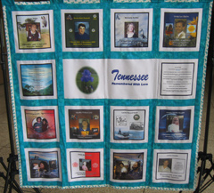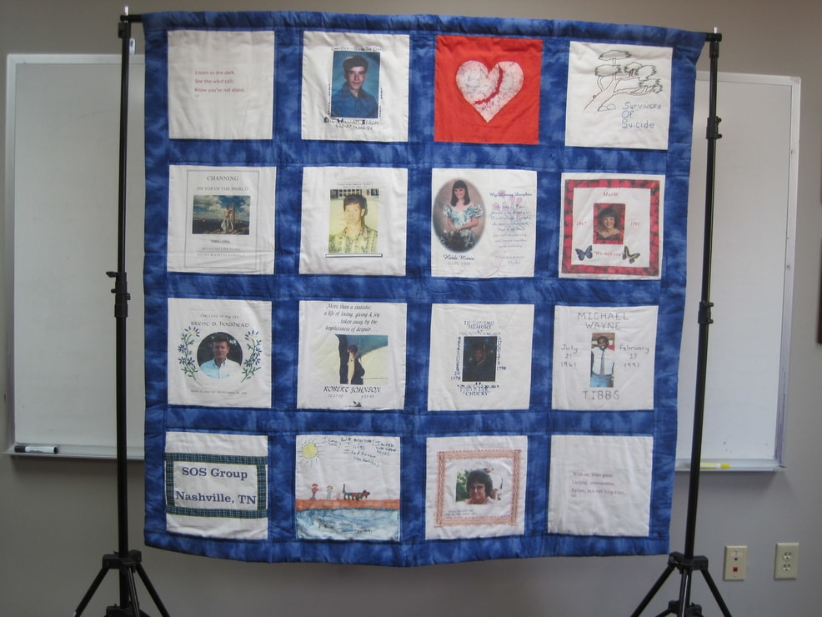

Mental Health America of Middle Tennessee is blessed to have contract with the TN Dept of Mental Health and Substance Abuse Services for the Tennessee Suicide Prevention Network. We applaud our staff for their ongoing, statewide collaboration with MHA of East TN, many state departments, 8 regional councils, community mental health centers, emergency departments, and others. However, this award is warranted because of the many lives they save across Tennessee through prevention, postvention, training, and advocacy.

